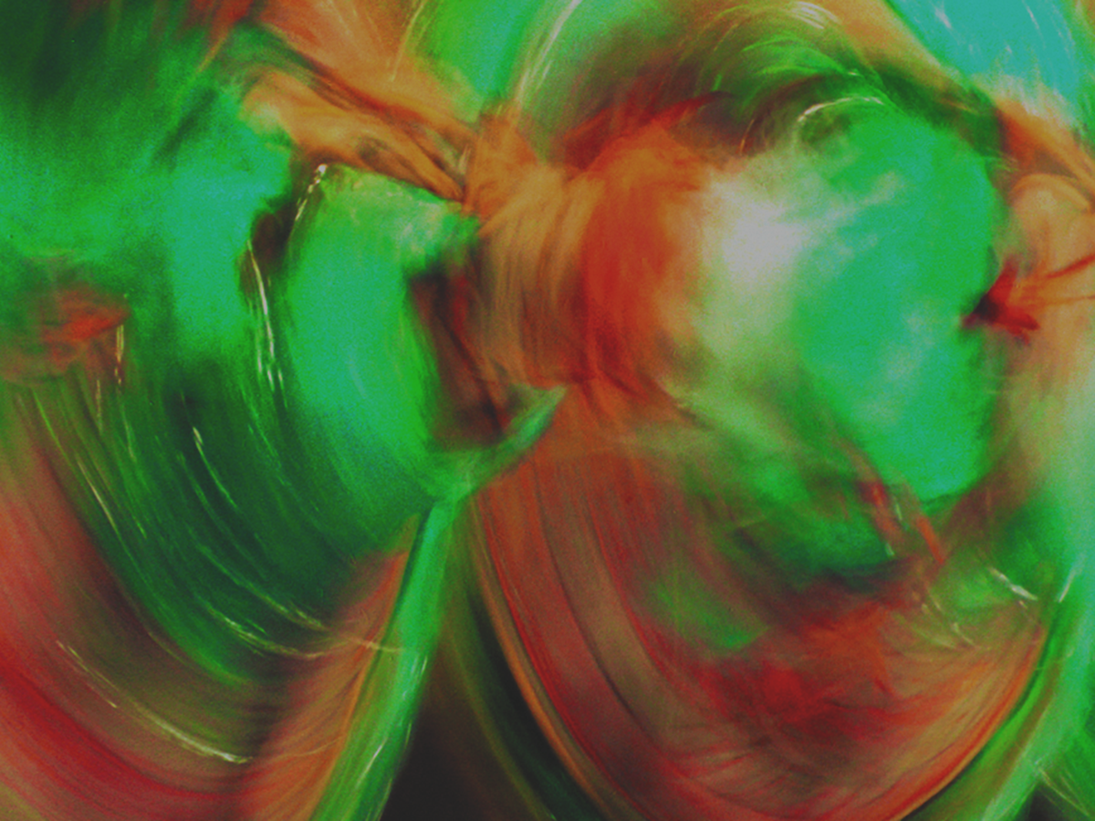

Expressive Art Work Shop

This group will use mixed media paper and watercolors, acrylic paints and pencils to provide a creative and fun format to express yourself or just do something fun and different. There is no cost to participants; supplies will be provided.

This is a six week group starting Saturday, March 16, 2019 from 9:00-11:00. Space is limited to 15 veterans.

If not enrolled at Vet Center, please bring copy of you DD214 and/or your VA ID to first group or drop off a copy at the Vet Center.

Meetings are held on Saturdays from 9:00-11:00 am at
The Billings Vet Center
2795 Enterprise Ave, Suite 1
Billings, MT 59102
Contact the Billings Vet Center at 406-657-6071 and reserve your spot.

