Dates subject to change as needed by MT Army National Guard
For Office use only
FLIGHT 1 2 CHINOOK
BLACK HAWK
Confirmed
In Database
____IN EVENTPLUS

Check the flight you are able to attend:

____TUESDAY 26 March- Missoula registration due 14 March
____TUESDAY 16 April- Butte registration due 3 April
____TUESDAY 14 May- Culbertson registration due 2 May
____TUESDAY 21 May- Kalispell registration due 8 May
____TUESDAY 09 July- Helena registration due 20 June
____TUESDAY 23 July- Laurel registration due 10 July

Return registration to: Parker Sullivan Montana ESGR VST 406-791-0895 parker.f.sullivan.ctr@mail.mil

Please print legibly and fill in ALL requested information required for flight
Your Formal Name:___________________________________________________________
Business: Title:

Address: City: State: MT Zip:

Work Phone: Email:

Home Address:___________________________________________________
Physical Address for Emergency Purposes
City: State: MT Zip: Cell

Medical Conditions/Prescriptions/Allergies/ Special Diet: N/A or _____________

US Citizen? Please circle: YES NO

EMERGENCY CONTACT INFORMATION

Emergency Contact: Relationship: Spouse Friend Relative Other

Phone:
Information needed for boss attendance and if contact with boss cannot be made
This section to be filled out by Reserve Component Members if nominating their employer
Reserve Component Member:

Branch of Service Unit ______________________Commander’s Name: _________________
Cell: __________________________________
Home Email so we may contact your outside of drill weekends: _______________________________

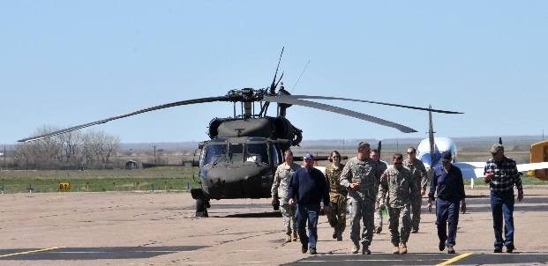
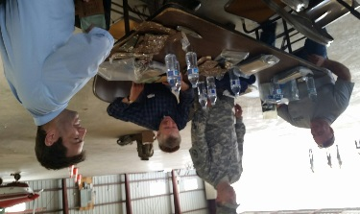
Take the ride of a lifetime
Montana Employer Support of the Guard and Reserve (Montana ESGR) invites you to hop aboard a Montana Army National Guard UH-60 Black Hawk, CH-47 Chinook.

Current and future Reserve component employers take a behind-the-scenes look at the efforts Montana Guard and Reserve members put forth each time they put on a uniform to serve. During the boss lift, employers will receive mission briefings, an ESGR overview, and participate in a training mission. Learn how vital the guard and reserve is to the defense of our nation and how employer support makes it all work. ESGR does not provide mileage/hotel or per diem for bosslift guests.

FY 2019 BOSSLIFT LOCATIONS AND REGISTRATION DUE DATES - You will be notified once times are confirmed. Event can run 9:00 am to 3:00 pm depending on when the flights arrive in your town.

City Locations
TUESDAY 26 March- Missoula registration due 14 March
TUESDAY 16 April- Butte registration due 3 April
TUESDAY 14 May- Culbertson registration due 2 May
TUESDAY 21 May- Kalispell registration due 8 May
TUESDAY 09 July- Helena registration due 20 June
TUESDAY 23 July- Laurel registration due 10 July

Boss lift rules:
- Limited seating first come, first served
- Employer has not previously attended a boss lift
- Must be 18 years of age or older
- Reserve component nominator does not fly
- Flights are assigned you do not choose
- No more than 3 bosses per business or Service Club leadership
- No persons seeking election or current officials who are campaigning for reelection
Please fill out the registration form and email or call information to: Parker Sullivan MT ESGR Volunteer Support Technician at parker.f.sullivan.ctr@mail.mil 406-791-0895.
Montana ESGR is an agency of the Department of Defense seeking to develop and promote a culture in which all American employers support and value the military service of their employees. We recognize outstanding support, increase awareness of the Uniformed Services Employment Reemployment Rights Act (USERRA), and resolve conflicts through mediation. Montana ESGR is your resource for connecting with employees in the Montana Guard and Reserve.

OPERATION BOSSLIFT FY19
Montana Employer Support
of the Guard and Reserve

